

# **LAB REPORT 3**

**LRC CIRCUITS**

**Date of Experiment: 10/11/2023**

**Date of Report: 30/11/2023**

**Members:**

1. Đỗ Minh Duy - ITITSB22029

2.Ngô Tùng Chương – ITITDK22116

3. Bùi Duy Đức – ITITIU22033

4.Nguyễn Minh Duy - ITITIU21186

5.Mai Văn Vinh ITITDK22117

1. **LC Oscillations**

**Theoretical values:**

Inductance: 0.028 H

Capacitance: 10 µF

Angular frequency (theory): 1890 rad/s

**Experimental data:**

Time at max/min current: 0.034 s

Time at next max/min current: 0.038 s

Time difference: 0.004 s

Period: 0.004 s

Linear frequency: 250 Hz

Angular frequency (experiment): 1570.8 Hz

Compare the angular frequencies between theory and experiment: Base on all the values given above, the angular frequencies in experiment lower than in theory show that the time required to reach the highest current is must slower than the theory expected. And that led to the result we received in experiment.

1. **Resistive Circuit**

Resistance: 10 Ω

Period of the AC voltage: 0.01 s

Time at max/min current: 0.0125 s

Time at max/min voltage: 0.0125 s

Time difference: 0 s

Phase difference: 0 rad

Compare the phase difference with the value predicted by theory: The values received in experiment equal to the prediction of the theory when the times it required to meet the peak and the minimum are alike.

1. **Capacitive Circuit**

Capacitance: 10 µF

Period of the AC voltage: 1.04*10-3 s

Time at max/min current: 0.001 s

Time at max/min voltage: 0.0013 s

Time difference: 0.0003 s

Phase difference: 1.81 rad

Compare the phase difference with the value predicted by theory: Base on the data received in the experiment above, we can conclude that there are the difference between the current and the voltage due to the phase difference is 1.81 rad. However, the time difference is just insignificant 0.0003 s less than 1 s so we hardly can affirm the time difference between them.

1. **Inductive Circuit**

Inductance: 0.028 H

Period of the AC voltage: 0.01 s

Time at max/min current: 0.0125 s

Time at max/min voltage: 0.0105 s

Time difference: 0.002s

Phase difference: 1.26 rad

Compare the phase difference with the value predicted by theory: According to all the data we got from experiment along with given theory numbers. The conclusion have been made due to the difference of phase and time. The variation of phase is 1.07 rad and the time is 1.7*10-3 s. Despite the fact that all the difference is hardly notice.

1. **LRC Circuit**
2. Inductance: 0.028 H

Resistance: 10 Ω

Capacitance: 10 µF

Frequency at which current reaches its max: 250 Hz

1. Inductance: 0.028 H

Resistance: 56 Ω

Capacitance: 10 µF

Frequency at which current reaches its max: 250 Hz

Compare the angular frequency in LRC circuit with the one in LC Oscillations. Does the frequency change when the resistance changes?

There are exist no difference between the frequencies when the resistance is 10 Ω and the resistance is 56 Ω. In fact, the only variation we can get are the current.

Does the resistance affect the high of the peak? If yes, show your experimental data and explain.

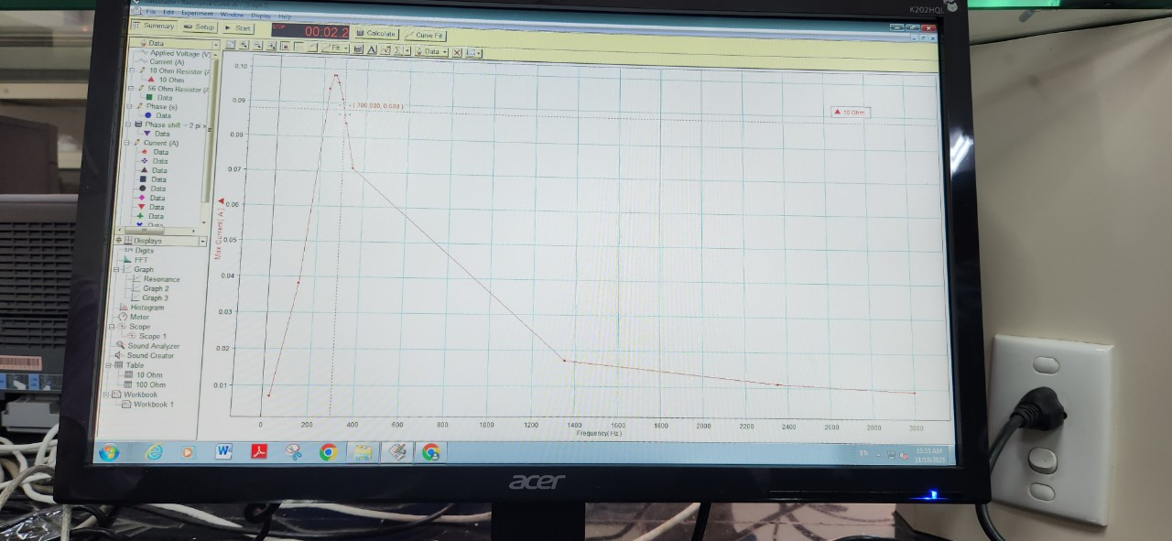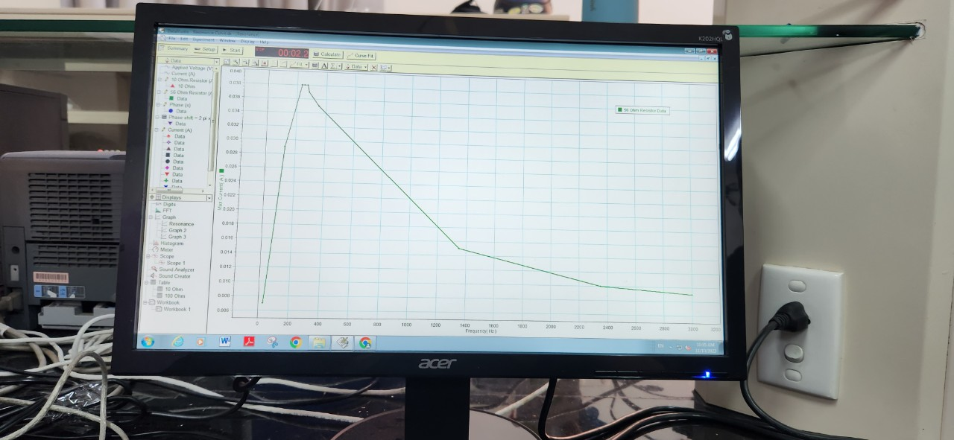

Yes, it does effect the high of the peak of current. Due to the equation Ω(omega) = 1/√LC so even though the resistance are variety, the high of the peak are not changed.